Checkerspots & Crescents
Harris’s Checkerspot Chlosyne harrisii
Pearl Crescent Phyciodes tharos
Northern Pearl Crescent ↓ Phyciodes cocyta
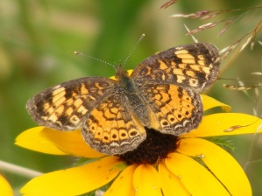
Eastern Comma Polygonia comma
Mourning Cloak Nymphalis antiopa
Red Admiral Vanessa atalanta
American Lady ↓ Vanessa virginiensis
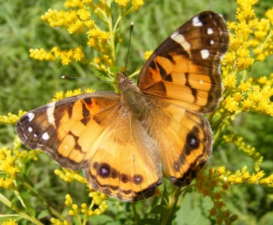
White Admiral Limenitis arthemis
Viceroy* Limenitis archippus
______________________________________
______________________________________

Satyrs
Northern Pearly-Eye Enodia anthedon
Eyed Brown ↓ Satyrodes eurydice
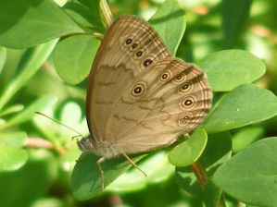
Little Wood Satyr Megisto cymela

Inornate Ringlet ↓ Coenonympha tullia
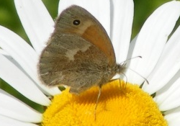
Common Wood Nymph ↓ Cercyonis pegala
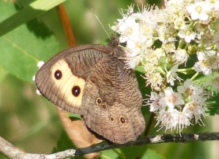
______________________________________
______________________________________
______________________________________
______________________________________
______________________________________

*Observed but unconfirmed.
All other species in this checklist are confirmed.
Bolded species name is followed by a photo of the species.

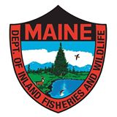

Checklist created by Robert E. Gobeil and Rose Marie F. Gobeil in cooperation with the Maine Department of Inland Fisheries and Wildlife (MDIFW).

Butterflies of
Swan Island

Perkins TWP, Maine
Steve Powell Wildlife Management Area

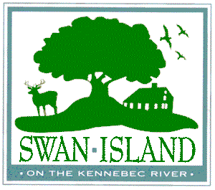

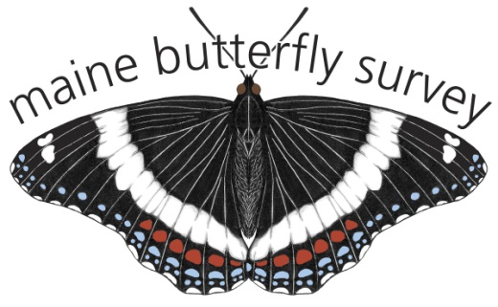

LINKS:
Maine Butterfly Survey
http://mbs.umf.maine.edu/
Photos of Maine Butterflies
http://www.mainebutterflies.com/

Skippers
Silver-spotted Skipper ↓Epargyreus clarus
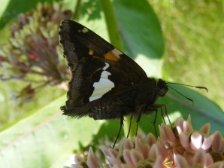
Northern Cloudywing Thorybes pylades
Least Skipper Ancyloxypha numitor
European Skipper Thymelicus lineola
Indian Skipper Hesperia sassacus
Peck’s Skipper ↓ Polites peckius
Tawny-edged Skipper Polites themistocles
Long Dash Skipper Polites mystic
Northern Broken Dash Wallengrenia egeremet
Hobomok Skipper ↓ Poanes hobomok
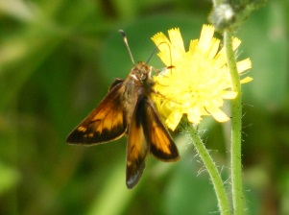
Dun Skipper ↓ Euphyes vestris
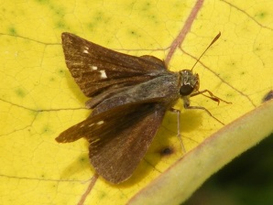

Pepper & Salt Skipper Amblyscirtes hegon
______________________________________
______________________________________
______________________________________
Swallowtails
Black Swallowtail* Papilio polyxenes
Canadian Tiger Swallowtail ↓ Papilio canadensis
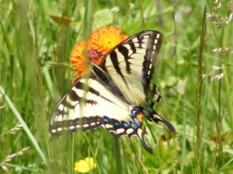
______________________________________
______________________________________
Sulphurs
Cabbage White Pieris rapae
Clouded Sulphur ↓ Colias philodice
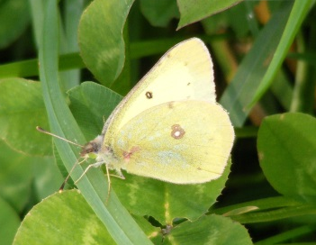
Alfalfa Butterfly Colias eurytheme
______________________________________
______________________________________
Coppers, Hairstreaks & Blues
American Copper Lycaena phlaeas
Bronze Copper ↓ Lycaena hyllus
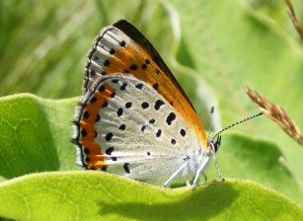
Eastern Pine Elfin* Callophrys niphon
Banded Hairstreak ↓ Satyrium calanus
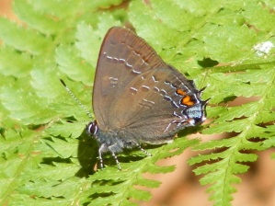
Eastern Tailed Blue ↓ Cupido comyntas
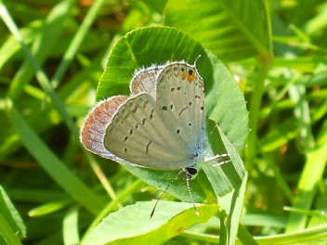
Cherry Gall Azure* Celastrina seritona
Silvery Blue Glaucopsyche lygdamus
______________________________________
______________________________________
______________________________________
Fritillaries
Great Spangled Fritillary Speyeria cybele
Aphoodite Fritillary Speyeria aphrodite
Silver-bordered Fritillary ↓Boloria selene
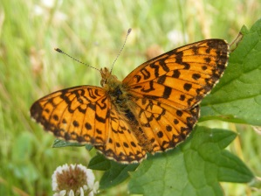
Meadow Fritillary Boloria bellona
______________________________________
______________________________________
______________________________________
______________________________________
______________________________________
______________________________________
______________________________________

